**Daniel Williamson**

**Project #9**

**11/28/16**

**CS 212**

[**http://cefns.nau.edu/~daw277/index.html**](http://cefns.nau.edu/~daw277/index.html)

Project Overview

Purpose:

The purpose of this project was rather simple. After some reviewing of what we needed to accomplish and doing some research online it was obvious I did not need a whole lot of code. Essentially we are doing what we did in PHP for our contact page, but in JavaScript. We are just checking to see if the form was filled out completely on the client’s side as opposed to the sever side.

Approach:

To begin, I knew I had to just change up my contact form to get the JavaScript to work properly. I needed to add a couple more functions to my functions page, which is where JavaScript actually starts. In my contact page I call, onblur, to see if the field has been filled out. If after clicking into the field and then leaving that field, you will activate the onblur, which will notify you if the field was not filled out. If it is filled out, it will not pop up anything. For some extra flavor I also made it so it highlights the field that did not get filled out properly.

After you have filled out some fields, you can hit the send button. If a field was not filled out, even after being notified the first time, it will once again let you know that not all the fields have been filled out properly and will not send the information to the server.

Results

These are my results.

If you entered a field and then leave that field without entering information:

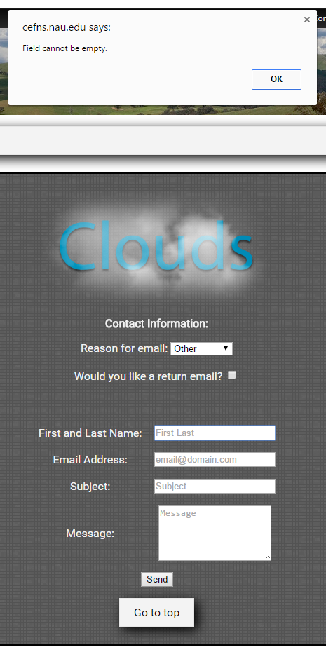

The flavor added, which highlights the box:

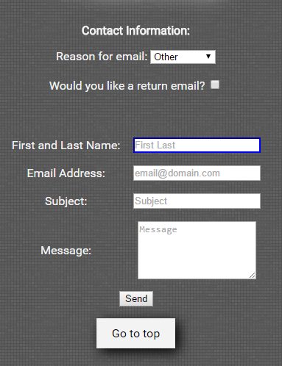

If you hit send without all the fields being filled:

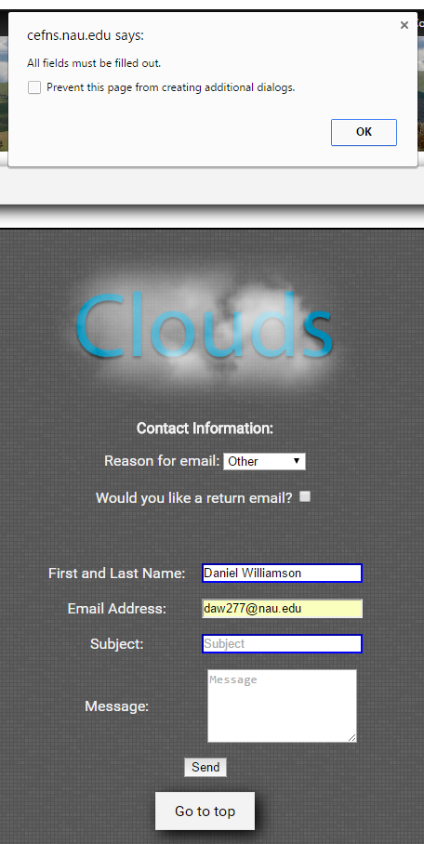

Conclusion

In conclusion, this was a rather easy lab. There wasn’t a whole lot to it. The only problems I encountered were getting the JavaScript to work properly. Knowing key words and functions. The internet helped a lot, just like most of the other projects. All in all, I learned a lot about how JavaScript works.